**Web Designing Assignment**

**Term-1**

**Modul (HTML) -1**

1. **Are the HTML tags and elements the same thing?**

**Ans :**  No, there are Both work Differently.

HTML tags define a way to represent and hold HTML elements in the program.

HTML element holds the content.

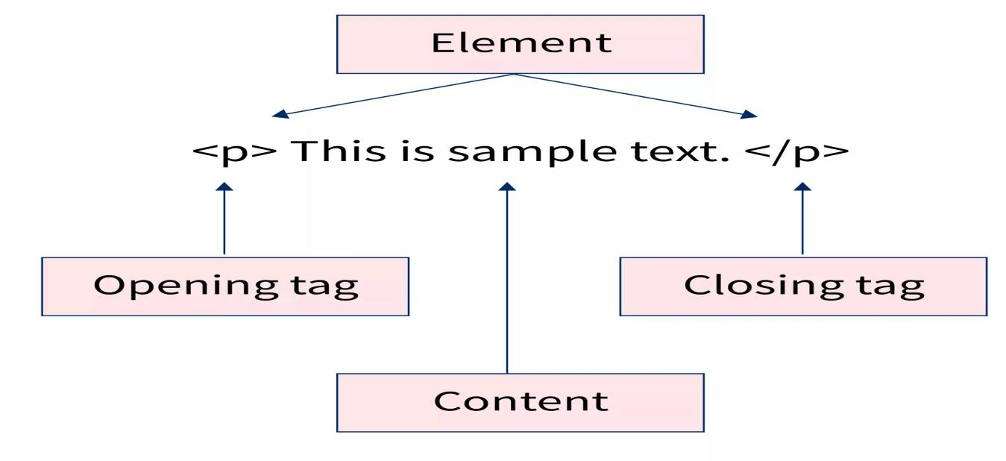

1. **What are tags and attributes in HTML?**

**Ans**: HTML tag starts with < and ends with > and attributes are found only in the starting tag.

 HTML attributes are used to describe the characteristic of an HTML element in detail.

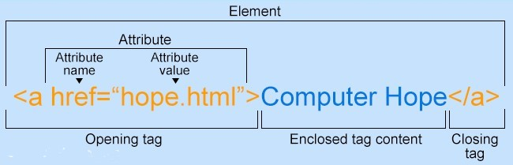

1. **What are void elements in HTML?**

**Ans:** Void elements only have a start tag they are don’t have end tag.

Ex= <hr> = Create Horizontal line,

<br> = Create a new Line

<img src= “”> = Used for add image, etc.

1. **What are HTML Entities?**

**Ans:** Symbols which are not present in keyboard and we want to use in HTML code or Web Page so we can use entities for add Symbols to web pages.

Ex= icons, geometric shapes etc.

1. **What are different types of lists in HTML?**

Ans: There are 3 different tags in HTML to represent all different types of lists.

1- Ordered lists <ol> = Order lists are used for making sequence lists mainly with numbers and also using capital and small alphabets or roman numbers.

2- Unordered lists <ul>= unordered lists, items are marked with bullets and we use also circles

3- Definition list <dl> =: Define List is used to give a definition or description to a term and <dd> is used for give descriptions.

1. **What is the ‘class’ attribute in HTML?**

**Ans:** The HTML class attribute is used to specify one or more class names for an element. The class attribute points to a class in a style sheet.

1. **What is the difference between the ‘id’ attribute and the ‘class’ attribute of HTML elements?**

**Ans**: In html both id and class are the element selector and are used to identify an element based on the name assign to these parameters. The basic difference between ID and Class is that the ID selector name is used one time, and the class selector name can be used to multiple on a single page.

1. **What are the various formatting tags in HTML?**

**Ans**: HTML offers a range of tags that can be used to format text, including:

1. Bold text: <b> or <strong>
2. Italic text: <i> or <em>
3. Underline text: <u>
4. Strike-through text: <del> or <s>
5. Superscript and subscript text: <sup> or <sub>
6. **How is Cell Padding different from Cell Spacing?**

**Ans**: In HTML table formatting, cellpadding is the attribute which is used to set the whitespace between the cell edge and the cell content.

cellpadding is the attribute of the table tag (<table>) that set the distance between the cell border and cell content.

1. **How can we club two or more rows or columns into a single row or column in an HTML table?**

**Ans**. In HTML, you can combine cells in columns or rows by using the special attributes colspan for join two or more row and rowspan used for combine two or more columns in table.

1. **What is the difference between a block-level element and an inline element?**

**Ans**: in HTML, block-level element is always start from new line and inline element never start from new line.

Block level element is taking full space from left to right. Inline element is only taking element’s space it is not take full width of tag.

<p>, <br>, <hr> etc. are block- level elements.

<b>, <i>, <strong>, <span> etc are inline elements.

1. **How to create a Hyperlink in HTML?**

**Ans**: In HTML for creating hyperlink there is use anchor tag which is start with <a href=” here add url”> and end with </a>

Example =



1. **What is the use of an iframe tag?**

**Ans**. In HTML use of an iframe is to load content from another site within the page. Also use for advertisement in web pag. It can be used to display a web page within a web page.

1. **What is the use of a span tag? Explain with example?**

**Ans**: In HTML <span> tag is mainly used for grouping of elements and applying styles accordingly to the inline elements.

Ex.



Here is output.



1. **How to insert a picture into a background image of a web page?**

**Ans**. There is an attribute to insert background image in web Page also we can use css for background image with url.

Example =

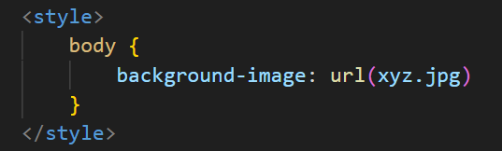

1. **What are the different tags to separate sections of text?**

**Ans**: For the separate section of text, we are use <br> tag it is for in line separation, also use <p> tag for paragraph separation and also use <blockquote> tag for separate section.

1. **What is SVG?**

**Ans**: Scalable vector Graphics. It is used for drawing circle, polygon, square, box, star etc. in web page.

1. **What is difference between HTML and XHTML?**

**Ans**. HTML does not have a case sensitivity nature hence the codes can either be written in uppercase or lowercase. But in XHTML is case sensitive language, only lower case is used. In html error can be easily rectified but in XHTML is not easily rectifiable.

1. **What are logical and physical tags in HTML?**

**Ans**: Logical tags are used to indicate to the visually corrupt that there is some focus on the text. for that we are used tags like <em>,<strong>,<cite>.

Physical tags are used for special characters formatting.

Ex- <b>for bold text, <i> for italic text, <big> for large font.

in this <strong> and <b> tags output is same but concept is different

**Pending**

* How are active links different from normal links?

(Pending css lecture)